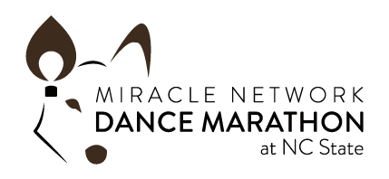

Dear ,

This year I have decided to participate in Dance Marathon at NC State’s Dance Marathon on March 6th, 2021. Dance Marathon at NC State is a year-long fundraising effort that ends with a celebratory event in which hundreds of NC State students come together to stand (and dance) for 12 hours in honor of the children being treated at Duke Children’s Hospital who can’t. At the event, we will play games, visit with our Miracle Kids from Duke, watch performances, and celebrate all that we have raised for Duke Children’s. Dance Marathon at NC State is entirely student-run and 100% of funds raised go directly to the Children’s Miracle Network at Duke Children’s Hospital.
Last year Dance Marathon at NC State was able to raise over $70,000, bringing our all-time total to over $410,000 for the kids! This year we are trying to raise even more. I have set a personal goal of $ before our event in March. Please consider supporting me by making a donation. Every dollar will go directly towards providing life-saving treatments to the kids of Duke Children’s.

Thank you so much for your support in making this year’s event a success!
For the Kids,

________________________________

Please cut on dotted line and include with your check.

Student Name: ____________________________
Donor Name: _____________________________
Donor Email Address: ______________________
Donation Amount: $25 $50 $100 Other Amount: _______
Donations can be mailed to: Duke Children’s Office of Development
Attn: Jocelyn Pietro
300 W. Morgan Street
Durham, NC 27701

All checks should be made payable to Duke Children’s Hospital

Online donations can be made at https://events.dancemarathon.com/event/NCSU2020
and then search for the student’s name.

Please cut on dotted line and include with your check.

Student Name: ____________________________
Donor Name: _____________________________
Donor Email Address: ______________________
Donation Amount: $25 $50 $100 Other Amount: _______
Donations can be mailed to: Duke Children’s Office of Development
Attn: Jocelyn Pietro
300 W. Morgan Street
Durham, NC 27701

All checks should be made payable to Duke Children’s Hospital

Online donations can be made at https://events.dancemarathon.com/event/NCSU2020
and then search for the student’s name.

